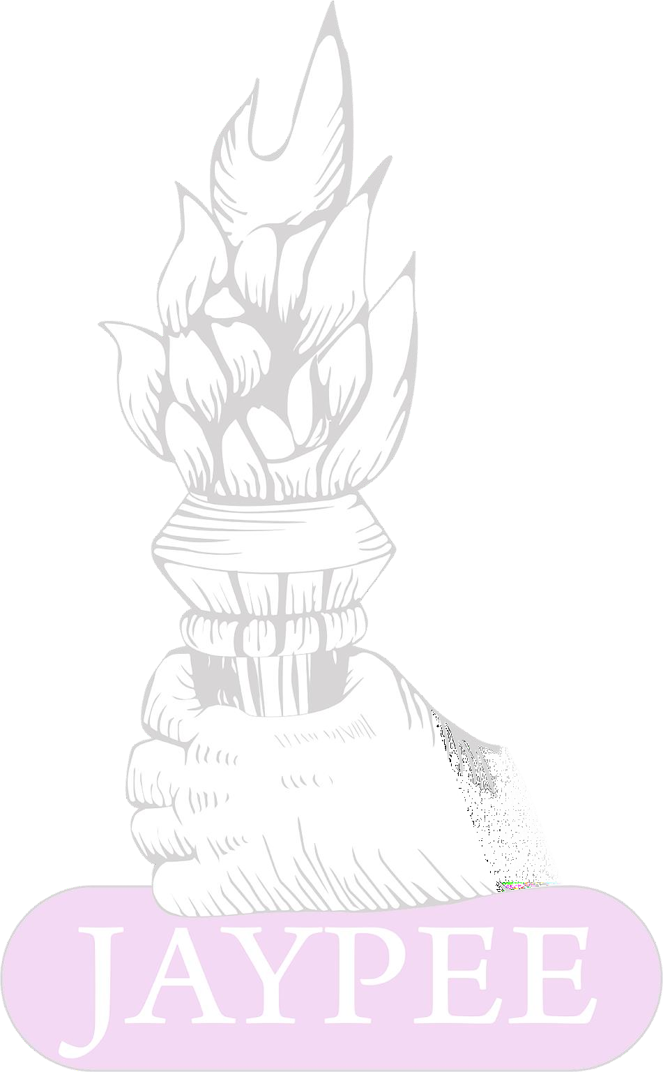
Indian Journal of Respiratory Care (eISSN: 2321-4899, pISSN: 2277-9019)

Submission Form
Manuscript title....................................................................................................................

- The author(s) certify that the manuscript submitted represents valid, original work and has not been submitted elsewhere and will not be submitted for publication elsewhere while under consideration by Indian Journal of Respiratory Care.
- This manuscript has been published as a preprint in (preprint
server name), under the title
… , doi:
… or URL
………………………………………………………………………………………………………………………………….

- The submitted manuscript is a translated material from a published article. If yes, the authors should have obtained permission for republication. The authors should indicate during the submission process that the article has been translated and the authors must also cite the original article in the submitted manuscript.
- The submitted manuscript has been published as a conference abstract. Details: ……………………………
(the conference name and the details of the published abstract including the citation details, doi)
- The author warrants that this Work contains no libellous or unlawful statements and does not infringe on the rights of others. If excerpts (e.g., text, figures, tables, illustrations, or audio/video files) from copyrighted works are included, a written release will be secured by the authors prior to submission, and credit to the original publication will be properly acknowledged. The manuscript is not subject to copyright or other rights except my own.
- All the authors fulfil the authorship criteria as recommended by the ICMJE guidelines.
- All the authors have given final approval of the submitted manuscript and aware that the manuscript is submitted to the Indian Journal of Respiratory Care

Author name Signature
  - ………………………………………………………. ……………………………………………..
  - ……………………………………………………….. ……………………………………………..
  - …………………………………………………………. ………………………………………………
  - ………………………………………………………….. ……………………………………………….

